

Project name

(Using Machine Learning)

Name –
MCA 3rd Semester JULY-2022 (Machine Learning (TCS)) Enrollment No. -

DECLARTION

I, student of Master of Computer Application hereby declarethat the MINOR PROJECT titled, which is submitted by me to, Amity University Online, Noida, Uttar Pradesh in partial fulfilment of requirement for the award of the degree of Master of Computer Application, has not been previously formed the basis for the award of any degree, diploma or other similar title or recognition

Name and signature of student

CERTIFICATE

This is to certify that Mr SANIYA SHEKHANI has worked on the project entitled MART SALE for the partial fulfilment of the requirements Master of Computer Application. This bonafied work has been done by him under my supervision.

Signature of guide

PLAGIARISM REPORT

This is to certify that I of Master of Computer Application Semester III Minor Project/Seminar(Evaluation) Enrollment no. (el) Session 2023-2024 has submittedthe report.

The plagiarism has been checked through tool plagiarismdetector.net and it came out to be 100% Unique.

Name and signature of student

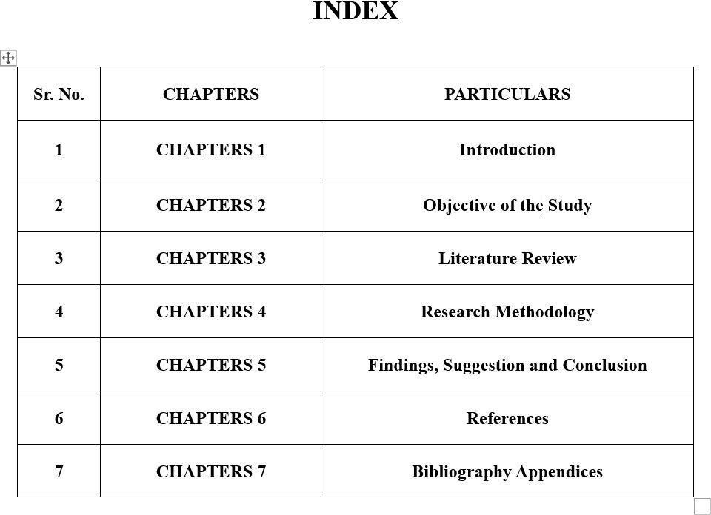

INTRODUCTION

ABSTRACT

LITERATURE REVIEW

RESEARCH METHODOLOGY

Methodology

CONCLUSION, FINDINGS, SUGESSION,

- Recommendations

BIBLIOGRAPHY AND REFERENCES
RESULT

